Milk Bottle Preview, Wills & Joanne Passmore Estate
Wilsons’ Auctions: 2018-04-14, 630 Taylor’s Bridge Road, Townsend, DE 19734

Sample Photos of collection of over 200 early 20th century bottles:

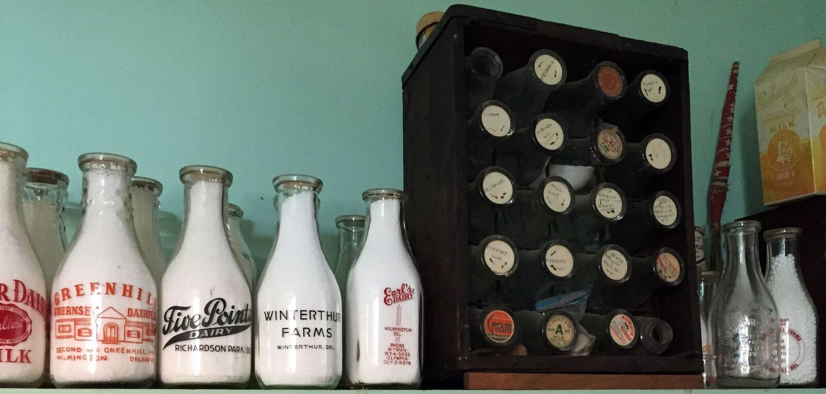

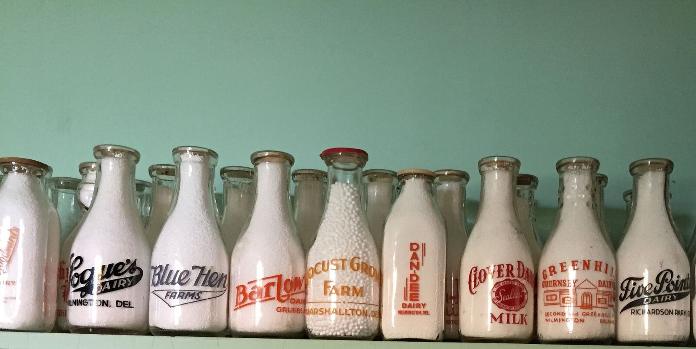

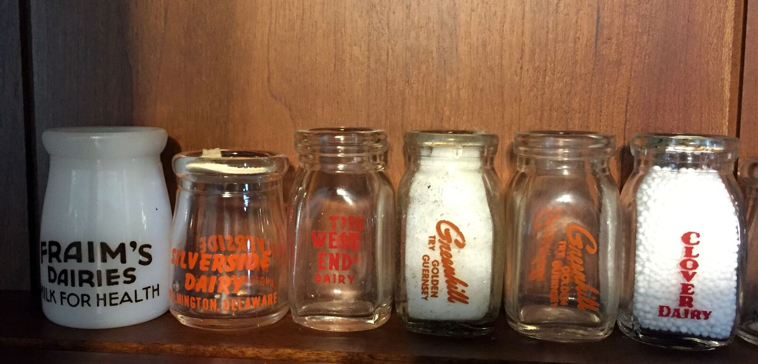

Lynthwaite Farm numerous assorted bottles from 1930s, 1940, 1950s: pints, quarts, half pints; embossed, black paint; round and square. Some dairy accessories.

Other Bottles from Delaware and Delaware valley area-all antique
- A Bottle of Milk is a Bottle of Health 1 gill
- A Bottle of Milk is a Bottle of Health quart embossed
- A Bottle of Milk is Bottle of Health half pint embossed
- A T Pike Maple Valley Farm quart embossed
- AC Ogden pint cream with street address and phone # no town
- Abbott’s Alderney Dairies pint embossed
- Abbott’s pint embossed
- Abbott’s quart embossed
- Acadia Dairies pint embossed
- B.T. Hopkins New Castle quart embossed
- Barlow's Dairy Grubbs, Del orange paint both sides quart
- Blue hen farms half pint Wilmington embossed
- Blue Hen Farms quart embossed
- Blue Hen Farms quart embossed cream neck
- Blue Hen Farms quart piro worn
- Blue Hen pint cream top embossed 2 sides
- Bottle caps: various
- Brandywine Dairy quart embossed Wilmington
- Breidablik Farm Dairy half pint embossed with lid Fox Den Breidablik
- Breidablik Farm quart embossed Wilmington
- Breidablik Farm quart piro
- Brookwood Farm Dairy quart piro
- Brookwood Farm Greenville pint embossed round
- Brookwood farm Greenville quart embossed
- Busy Bee Dairy Wilmington quart black paint both sides
- Clarks Dairies Tb tested Kirkwood NJ 1917 pint embossedClimes Dairy quart embossed Maryland
- Climes Dairy, Federalburg, MD embossed quart
- Clover Dairy half pint embossed
- Clover Dairy quart red paint seal test milk x 2 sides each w/ embossed clover above paint
- Clover Dairy quarter pint embossed
- Clover Dairy quarter pint Wilmington
- Clover Dairy Safe milk Wilmington embossed pint
- Connors Dairy quart embossed Wilmington
- Cooklyn Dairy half pint embossed Philadelphia
- Creamer red paint Raritan Valley Farm Somerville NJ
- D Crosslet and son quart embossed Clayton
- Dan Dee Dairy orange paint square qt with cap from Walt Lea farms West Chester PA photo
- Dan Dee dairy Wilmington quart orange paint 2 sides different see photo WW 2
- Danner's Dairy Dover Del. Orange paint quart
- Dela Exp Sta Uof D Newark DEL. embossed quart
- Delamore Dairy half pint embossed
- Delamore Dairy half pint embossed
- Delamore Dairy half pint Va-Len-Ju and embossed pattern over whole bottle
- Delamore Dairy quart embossed Wilmington
- Delamore Dairy Wilm De pint wide mouth light brown paint
- Delamore half pint embossed
- Delamore half pint embossed
- Delamore Products half pint embossed and painted
- Delamore Products quart piro
- Delamore Wilmington pint embossed
- Diamond Dairy pint embossed F.S.Snyder prop
- Diamond Sanitary Half pint embossed
- Diamond State Dairies (DSD) half pint piro
- Diamond State Dairies Dover De pint red paint
- Diamond State Dairies half pint piro
- Diamond State Dairies quart piro Kenton
- Diamond State Dairy Wilmington quart embossed
- Diamond State half pint piro Dover
- Dixie Cup Lids 4 with actors photos and 23 S.H.Ewing caps 107 red and white lids see 1 centerdel farm lids
- DSD embossed quart on one side; red paint "do you know? See photo
- E T Talley and son pint embossed Wilmington
- E. O. Hines Wilmington pint embossed
- E.F. Richards pint orange paint 1 side Newark
- Earls Dairy pint embossed
- Earls Dairy quart embossed
- Earl's Dairy Wilm De phone #s photo red paint on 1 side black on other
- Earl's Dairy Wilmington quart black paint
- Earls’s Dairy embossed quart
- Enterprise Mineral Water works grayish bottle Smyrna
- F. Flanzer Wilmington pint cracked-embossed
- Five Point Dairy H.H. Siemens quart Richardson Park quart embossed
- Five Points Dairy Richardson Park De w/ black paint at
- Foxden farm half pint orange paint
- Foxden farm quart orange paint
- Fraim pint Wilmington
- Fraim’s Dairies half pint piro wide mouth verse on back
- Fraim’s Dairies quart piro
- Fraim’s Dairies quart piro
- Fraim’s Dairy quart piro slogans
- Fraim’s half pint embossed
- Fraim’s half pint piro
- Fraim’s pint piro
- Fraim's Pint embossed square
- Fraim's Dairies brown paint/for victory buy United States war bonds. W/ embossed F above this and soldier to left quart Wilmington
- Fraim's Dairies half pint brown paint both sides Wilmington
- Fraim's Dairies Wilmington pint faded red paint 2 sides
- Fraim's Milk for Health quart Wilmington brown paint both sides
- Frear cottage cheese pint cartons 2
- Frear half pint Dover black paint both sides
- Frear half pint piro Dover
- Frear quart Dover black paint 1 side, orange with Peter pumpkin eater rhyme
- Granogue Farm pint Granogue Del embossed
- Granogue Farm quart embossed Granogue Delaware
- Granogue Farms quart red paint 1 side
- Granogue quart embossed 1 side
- Green Hill Dairy quart embossed Wilmington
- Green Hill quart piro
- Greenhill Dairy half pint embossed

- Greenhill Dairy phone 3-5836 orange paint/embossed
- GreenHill Dairy quart embossed
- Greenhill Guernsey Dairies/Guernsey barn on 2nd side; Greenhill Ave Wilm Delaware both sides in dark orange paint
- Hi- Grade half pint embossed
- Hi Grade Harrington phone 398-8321/different design red paint w/ cap
- Highgrade quart piro Harrington
- Highland Dairies half pint Doe Run PA
- Hi-Grade pint red paint
- Hill Cirt Farm quart embossed Chadds Ford
- Hilltop farm Del City quart embossed
- Hy- Point 75 anniversary as in 24
- Hy-point Dairy 75 anniversary quart piro Wilmington
- Hy-point Dairy Wilmington quart orange paint embossed face on neck
- Irving Sparks pure raw milk embossed at St Georges De Cap:”raw milk from tuberculin tested milk photo
- J M Mundy Hockessin De, M in middle of circle embossed at
- J Miillman M Wilmington DE embossed quart. Cap red print Cape May NJ
- J Millman quart embossed Wilmington
- J. W. Anderson pint Highland Dairy Wilmington embossed
- J.P. Zebley Wilmington half pint embossed
- J.T.Loder Clayton De embossed pint
- JAS Montgomery pint embossed Wilmington
- John Boyd pint Wilmington embossed
- John L. Hurd Smyrna pint blue paint
- Joseph W. Ennis Smyrna, De pint orange paint
- Koontz quart piro
- Krozycki Linden & Van Buren Sts quart embossed R in middle of embossed circle
- L G Griffith 8th & Adams Sts wilm De embossed. Crack in back of neck
- L.Millman pint a Wilmington embossed
- Larrimore pint embossed Seaford
- Lash's Bitters Company NY Chicago San Francisco wine/alcohol shaped bottle
- Locust Grove (A.J. Lindell) embossed quart
- Locust Grove Farm Marshallton Del quart goldfish paint different 2 sides a/ cap photo
- Locust Grove Farm quart embossed Marshallton
- Locust Grove Farm quart piro yellow Marshallton PA
- Logues Dairy half pint embossed
- Logues Dairy quart embossed
- Logue's Dairy Wilmington pint embossed
- Loque,s quartblack ink/embossed photo
- Lostens Dairy half pint embossed
- Lostens Dairy quart embossed
- Losten's Dairy, Chesapeake City, pint embossed square
- Mansion Farms Hopkins New Castle quart green paint
- Manston Dairy JT Hopkins half pint New Castle
- Maple Lawn Dairy quart embossed
- Maple Lawn quart embossed
- Maple Shade Dairy. C B Scwhwebel. Embossed Old plain cap w/ "Thur" handwritten in script. On neck is handed printed paper taped down: "Field Boro" DE
- Mark Brown (sl damage) embossed quart
- Mark Brown quart embossed Wilmington
- Middletown Farms Pint Middletown
- Milky Way Dairy half pint clearing printing malted
- Neff's Dairy Port Penn at embossed 1 side
- Richards Dairy cartoon half gallon Newark
- Richards Dairy cartoon quart
- Richards Dairy half pint piro
- Richard's Dairy Newark quart orange paint
- Richards Dairy quart piro Newark
- Richards Dairy quart piro Newark Brown Bottle
- Rosehill Dairies quart piro Wilmington
- Rosehill Dairy half pint embossed
- RoseHill Dairy quart piro
- Rosehill quart embossed Wilmington
- Rozycke linden and van buren Sts- S backwards Pint embossed
- S. F. Jackson Wilmington cracked pint embossed
- S.H. Foulness, pint embossed 1 side, homestead Farm, Del
- S.H. Ridgeway (sl.damage) embossed quart
- S.H. Ridgeway embossed quart
- S.H. Ridgway Wilmington pint embossed round
- Sanitary Dairy Dover De pint embossed one side 1/4 pint liquid with triangle with "t" on bottom with cap from Richard's Dairy (over edge )
- Sanitary Dairy quart Dover embossed
- Seal Test quart embossed
- Sealtest half pint piro
- SH Ridgeway quart embossed Wilmington
- SH Ridgway quart embossed Wilmington damaged
- Silverside quart piro
- State Bottling Company GoldBond Dover pint round embossed
- Steep Bank Farm Centerville De. Guernsey. W.D.Way milk quart
- Thompson' Dairy Dover Del pint brown paint both sides
- Twaddell Bros quart embossed Wilmington
- Twaddell half pint embossed and piro
- Union Dairy Wilmington De quart embossed on 1 side
- Unmarked 3 creamers (tiny with mark on bottom, no name)
- Unmarked creamer with hitchner Dairy cap Salem NJ
- We Armstrong quart Marshallton Del embossed
- West End Dairy half pint piro
- West End Dairy pint piro
- West End Dairy quart embossed
- West End Dairy Wilm De/ different design both in brown paint at
- William H. George pint Smyrna Del embossed including phone139-R-21
- Winterthur Farms pint embossed Winterthur Del
- Winterthur Farms Winhterthur Del black paint. 1 side at
- Winterthur Farms Winterthur De embossed 1 side at
- Wm Armstrong Marshallton, De quart green paint
- Woodwards Dairy quart Wilmington gold yellow paint

